ResLog user guide

Reslink screen manufacturing database

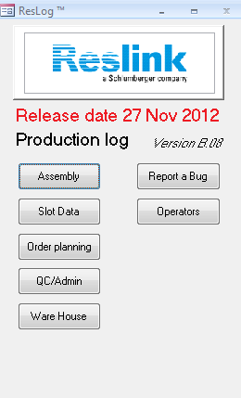

Part 1 – Administrator part

Table of Contents

Introduction 3

Revision history 4

Order and Work order registration 5

Order Reginstation 6

Work order Setup 7

Product details 8

Operations 10

Mfg Tests 12

Work o. BOM 14

Operation BOM 16

Slot requirements 18

Reports 21

Ware House 23

QC/Admin 26

ID status 26

Status 27

Pull off 28

Assembly 32

# Introduction

ResLog is a database developed to track details of the Reslink screen production. It is recording details of each screen joint as it passes through one or more manufacturing steps or operations. The information that can be recorded is:

* Wrapping process details
* Slot opening measurements and verification of slot requirements
* Process inspections and measurements
* Traceability of components

The system is intended to work integrated with MFG/Pro, but no automated link is made at this version; but the plan is on-going by RSLN ResLog project team. MFG/Pro is used to control manufacturing process at work order batch level and ResLog at joint level.

To use ResLog, the following sequences must be completed:

* The administrator (Usually Planners) enters work order details
* If component traceability is included, ware house team allocate parts at MFG/Pro first and inform the administrator to input traceability
* Operators record production data

# Revision history

|  |  |  |  |
| --- | --- | --- | --- |
| Version | Created | Released | Updates |
| B05 |  | 08 June 2012 |  |
| B06 | 11 June 2012 | 25 June 2012 | Bug fix on slot import function |
| B07 | 06 July 2012 |  |  |
| B08 |  | 27 Nov 2012 | Possible to select slot data only, new reports |

# Order and Work order registration

First step of administration is sales order and work order registration. Click ‘Order planning’ function and click ‘New order’ button to input sales order number. After sales order setup, choose the order number from the drop down list, and click ‘New WO’ to add work orders to the sales order (Figure 1)

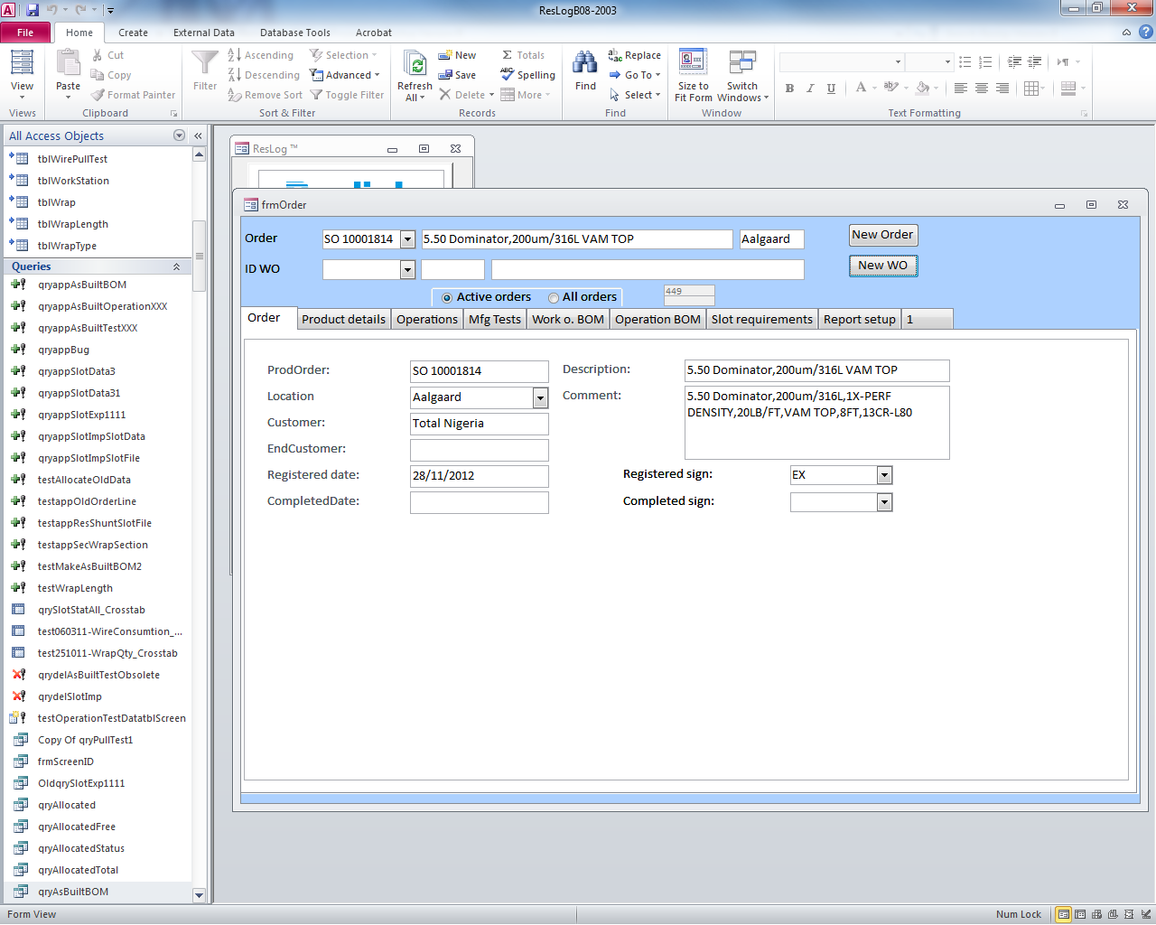

*Figure 1 New order and New WO registration.*

When entering data, click in the text box to see a descriptive text in the lower left corner.

The following information must be entered to use ResLog:

|  |  |  |
| --- | --- | --- |
|  | Description | Comment |
| Order | Top level order to one customer that may include several line items | To make new, click New Order |
| Product details | Record for one specific product with given part no and revision under the given order | To make new, click New WO  To populate database, click Generate records |
| Operations | Record at least one operation. The operation has to be linked to a work station. Wrapping and ResGauge are operations treated specially, but must also be defined as operations. | To populate database, click Generate records |
| Mfg Tests | Tests or questions that will require feedback from the operator | Optional |
| Work o. BOM | Bill of material as defined in GeMS or MfgPro | Optional, but required if traceability is to be recorded |
| Operation BOM | Components are linked to the given operations | Optional, but required if traceability is to be recorded |
| Slot requirements | Defines requirements to be used when importing data from ResGauge | Required if ResGauge work station is selected under operations |
| Report setup | Definition of reports based on manufacturing tests. Multiple reports can be defined. Each report can include up to 5 columns based on the defined tests. First column may also include weight increase of the given joint. | Optionalter |

## Order Registration

General information about the order is recorded (2). The purpose is to record sales order number and record information to make it easy to look up the order later. Description and Comment column should be from GeMs and registered sign need to be chosen by the administrator after order input.

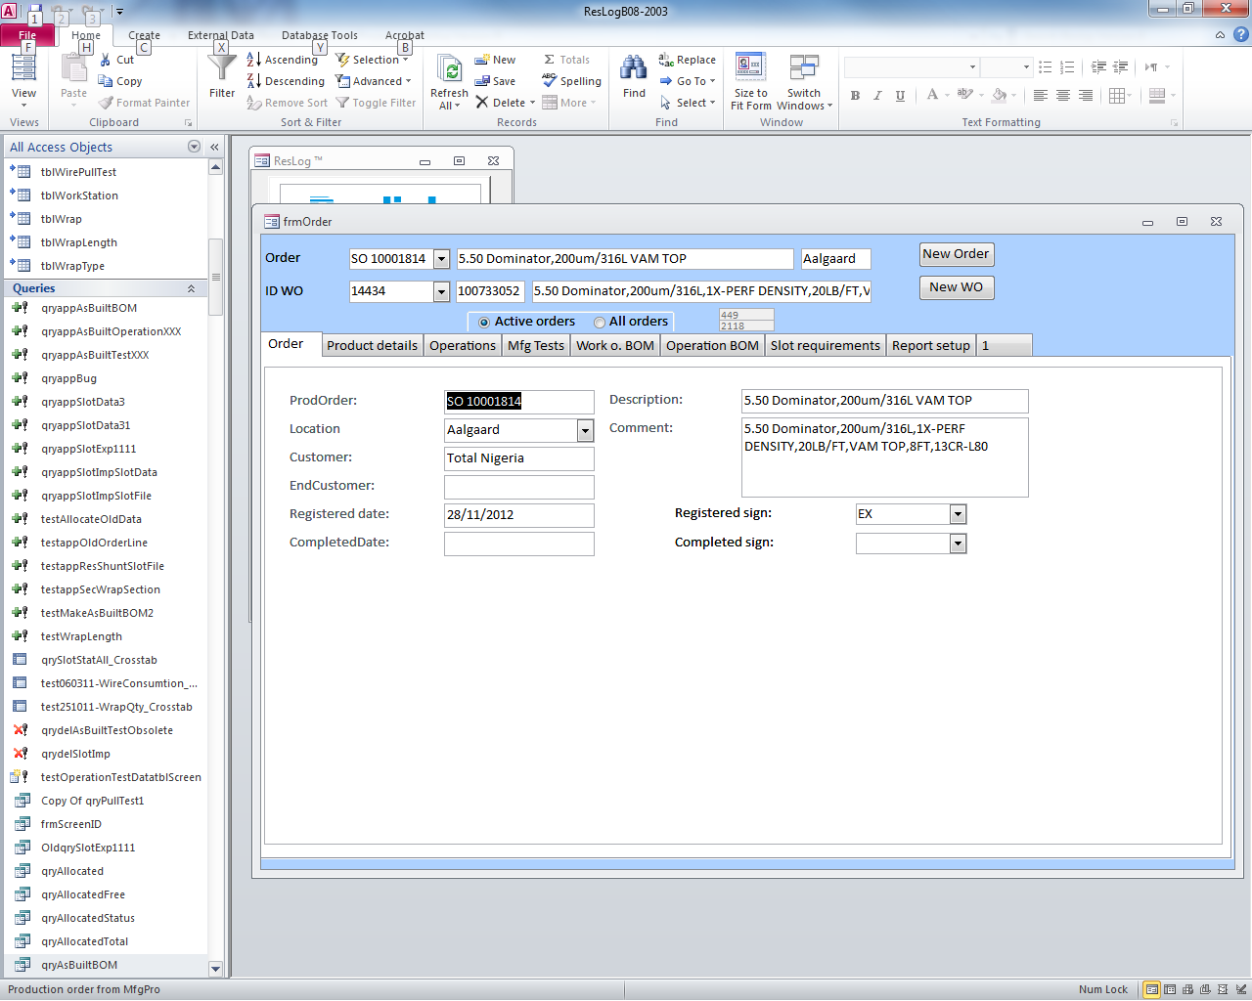

Figure 2 Order registration form

The ProdOrder is the sales order number as booked in MFG/Pro and ID WO is the auto-generated work order ID from MFG/Pro. To input a new work order, click on the New Order button. A new form is opened and the Order number can be entered. By closing the form, the record is stored and the order becomes selectable in order drop down list box.

Location must be selected to link the order and underlying work order(s) to a given production centre. Signature fields used on various forms are also linked to the selected location. After the work order is completed, the planner should login to this page again and choose ‘Completed sign’ to move the ResLog record from active orders to all orders This operation hides the order unless the All orders button is selected.

## Work order Setup

After sales order and work order registration in the system and all the required information of order input, the administrator should setup production information in ResLog per MFG/Pro and GeMs information. In the case of single piece flow and individual work orders for each screen joint, the ResLog database is designed to hold a group of individual MFG/Pro work orders within one ResLog work order. The individual MfgPro work order IDs can later on be assigned to the individual serial numbers in ResLog.

The administrator should choose the Order and ID WO from the drop down list, then click the blocks after ‘Order’ one by one to setup corresponding information of the work order per the following instruction.

### Product details

Choose tab ‘Products details’ and enter information as displayed at Figure 3 and click button Generate records. Required information in red boxes is being verified and records generated based on quantity and number of wrap sections and must be setup correctly according to the GeMs record. Usually all the information is at ‘Tab Data’ column of the GeMs record of the assembly number.The planner should inquire with quality engineer and manufacturing engineer if not sure with any of the red-highlighted column.

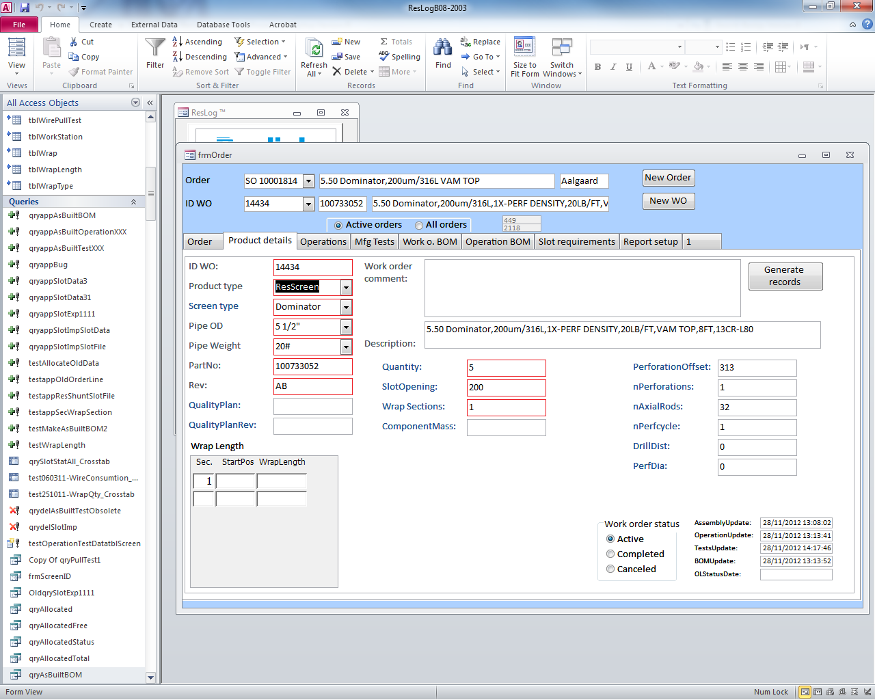

Figure 3 Product details form- Red highlighted ones as mandatory input

Wrap sections is the number of individual screen sections in the given product. Default is 1, while products like ResShunt may have 6 sections. Start position and wrap length may be entered. If entered, these values are used as default values in the wrapping process. If ResLog is being used to capture ResGauge data only, this information must be entered. Number of axial rods is also used to calculate axial wire consumption of the order besides order quantity, which means actual number of rods must be used without including shunt tubes for ResShunt.

Quantity of joints in a work order is editable and all the parameters could be re-write after setup. Each time when there is something updated at production details , “Generate records” must be run on this and subsequent forms.

After product details setup, the administrator should go to ‘Operations’ tab to continue order setup

### Operations

The different operations are defined and associated work stations are selected (4). Click “Generate records” to generate required records. New operations may be added later. In this case, “Generate records” must be run on this and subsequent forms. The operations usually are setup per standard operation drawing of assembly or ResShunt QCP for ResShunt joints. When not sure, the administrator should consult manufacturing engineer and production manager.

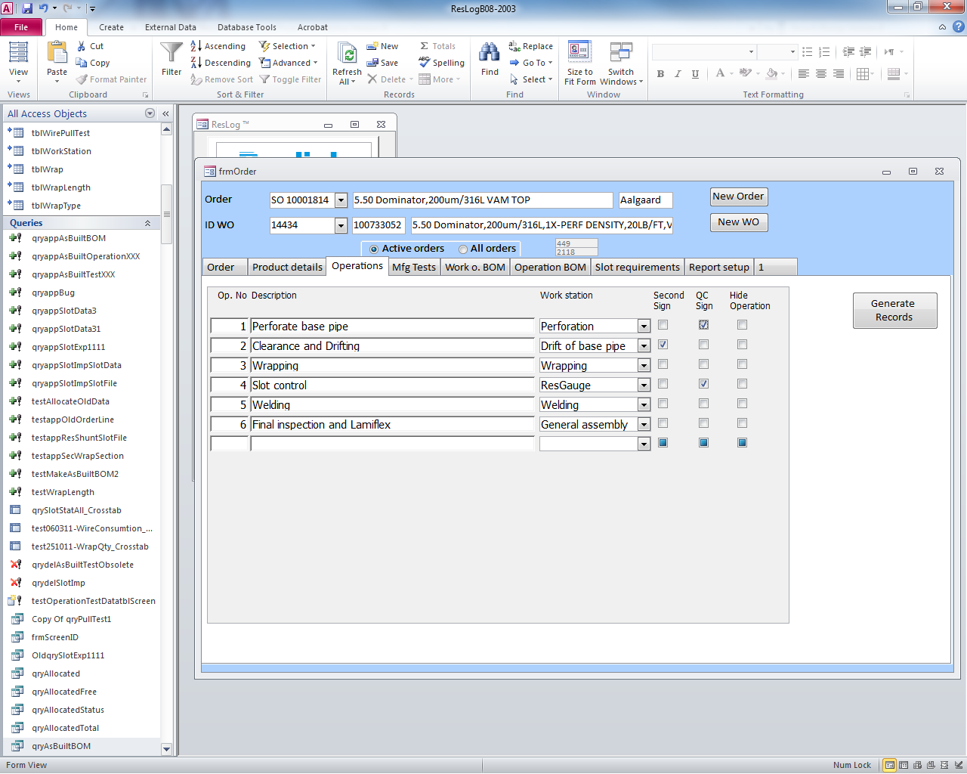

Figure 4 Operations form

The operation number (Op. No.) defines the sequential order of the operations. This is used both for sorting and to verify that previous operations have been completed.

Second sign is ticked off when an operation needs to be witnessed by a second operator or by a third party inspector

QC Sign is ticked off when an operation needs to be witnessed by Reslink quality team. The administrator should only tick the operations which are identified as QC witness from QCP’s.

Hide operation is used to remove the given operation from the manufacturing process. This may be used if too many operations have been entered or some operations are not input correctly at the first time.. If records generated, operations must not be renamed or linked to new work stations as this may cause problems with links related to manufacturing tests and operation BOM.

Description and work station may be edited at any stage. This will be reflected immediately in the manufacturing process. With all operations setup, click ‘Generate Records’ button and, the administrator should go to tab ‘Mfg Tests’ to continue.

### Mfg Tests

For each operation, operation tests may be defined (Figure 5). Each Mfg Test input needs to be linked to specific operations with the drop down list at ‘Op No’, which all the operations are identified at the previous step. ‘Op Test Text’ is used to identify the mfg test. Two types of Mfg Tests are legal to the system: Y/N or Num. Y/N test is identified as check point; while Num test is identified as a specific numeric requirement of a certain dimension.

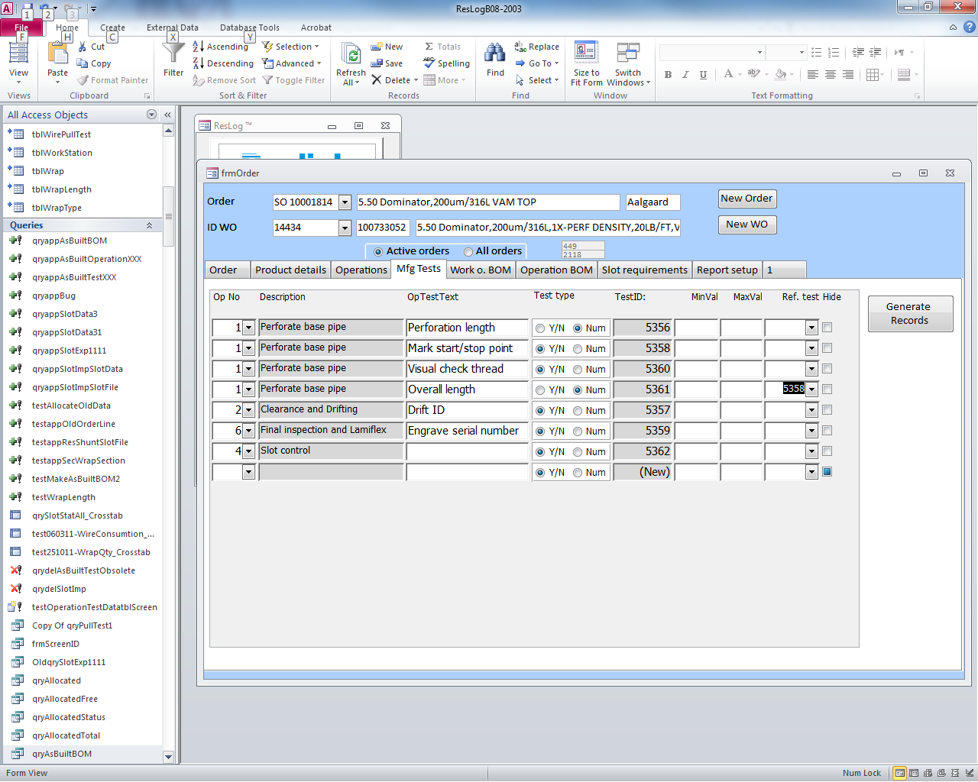

Figure 5 Manufacturing test form

Y/N test is allowed to input a comment. After input a Mfg Test, test ID is auto-generated by the system. If MinVal and MaxVal are entered, the input value is validated against the given value. The operator will not be able to type in a value falling outside of the defined rangeThe values may be edited without generating records.

After identifying the tests, checkbox of Y/N and input columns of Num tests will be generated at the corresponding pages of assembly function.

Reference a test to another test is also supported by the system. A third option is to reference a previously entered value (by operator) and define an offset values. In this case, the reference TestID must also be selected.

|  |
| --- |
| Example:  Base pipe length shall be between 9000 and 12000 mm and is actually measured to be 10400. Perforation length shall be 3000 mm shorter than actual pipe length with a tolerance of +/- 100 mm. In this case, reference is made to the base pipe length test using MinVal = -3100 and MaxVal = -2900. This will accept input values in the range from 7300 (10400 – 3100) to 7500. |

Click “Generate records” to generate required records. New operations may be added later. In this case, “Generate records” must be run on this and subsequent forms. Operation test text, MinVal and MaxVal can be edited without updating records. Hide test, removes the given test from the manufacturing process.

### Work o. BOM

Work order bill of material should be setup according to assembly part number BOM from GeMs (Figure 6). Input the part number of the components at ‘Partno’, revision at ‘Rev’, parts information at ‘Description’, quantity at ‘Qty. Choose the unit per GeMs records from the drop down list as ‘Kg’ or ‘Pcs’(EA). Only components should be input here and do not input specifications from the GeMs bill of material.

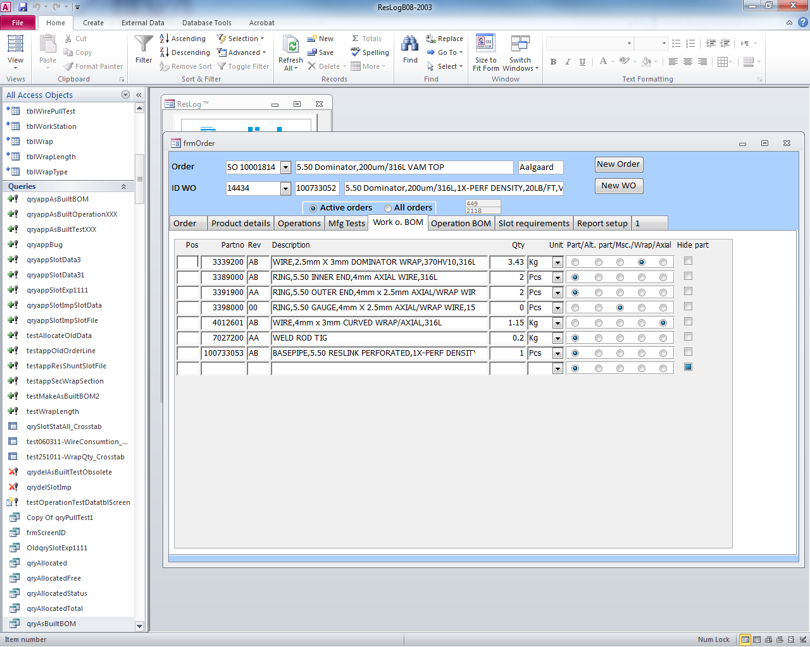

Figure 6 Work order BOM

Additionally, select part type from the five types of the components.

* Part – standard components exist at the assembly (default)
* Alt. part – alternative parts which differs usually from base pipes OD.. In this case, use same pos shold be used as the main part. Usually this option is used for different end rings according to different base pipes OD. The part number of the picked end rings should be from 13.77.5 setup of MFG/Pro.
* Msc – Manufacturing equipment identified at the assembly BOM, jigs and fixtures, documents or similar which are not consumables. This will be listed in the as built BOM, for reference only.
* Wrap – defines the wrapping wire and is required to link the part to the wrapping process
* Axial – defines the axial wire and is required to link the part to the wrapping process. Only standard wrapping wire shall be recorded and not components like shunt tubes or similar.

Hide part checkbox is used to delete or remove the components from manufacuturing process.

### Operation BOM

Operation BOM tab is used to link the components which are used in each operation. The administrator should link part to the corresponding operation (Figure 7). Select the operation from the drop list in which the part is going to be used. If a part is used in several operations, click “Part in new Op.” to duplicate the record and update Qty to reflect consumption in each operation. Qty with gray background is reference to initial BOM and is not editable in this form. After setup the operation and quantity, the components with detailed quantity will be displayed at assembly pages of the corresponding operation.

The setup is a key to function the traceability track later on at assembly process. The administrator should consult with manufacturing engineer if not sure.

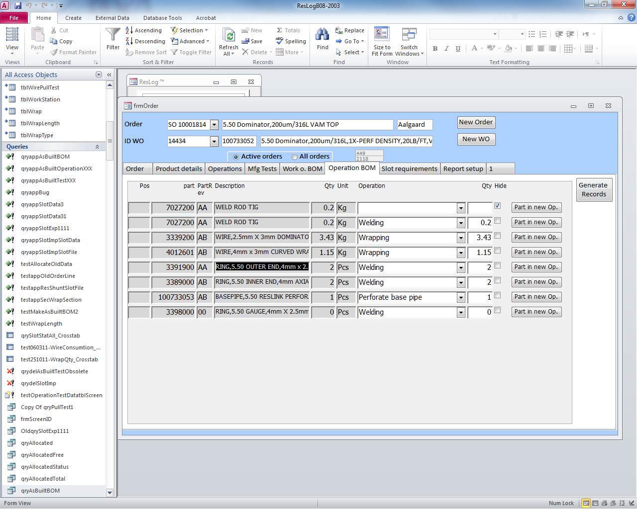

Figure 7 Operation BOM

Click “Generate records” to generate required records. New links to operations may be added later on and “Generate records” must be clicked again.

Hide checkbox is used to remove the given part from the given operation. The administrator should go to tab ‘Slot requirements’ after setup tab ‘Operation BOM’.

### Slot requirements

Slot requirements (Figure Figure 8) are looked up each time slot import and slot interpretation is run. Consequently, changes to some of the settings can lead to variation in interpretation of slot data. The general slot requirement of the slot should be found at the assembly drawing from GeMs record and the setup should be always following the quality control plan of the assembly part number. The red-highlighted items are the key parameters for ResGauge check.

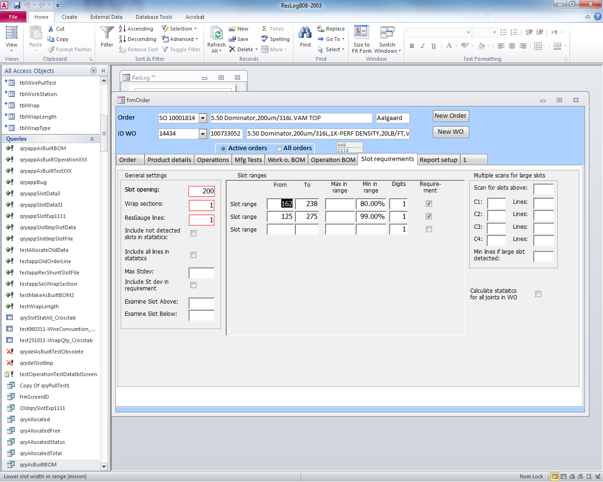

Figure 8 Slot requirement form

The detailed identification of each parameter is as the following list and the administrator should consult with manufacturing engineer if not sure. The input of the tab consists of ‘General settings’ block on left, ‘Slot ranges’ in the middle and ‘Multiple scans for large slots’ on the right.

#### General settings (Left side blocks of Figure 8)

|  |  |
| --- | --- |
| Enter information as listed and in accordance with the quality control plan.Slot opening: | The same value as set in the “Product details” tab. The value can be set under both tabs. |
| Wrap sections: | Number of screen sections on the joint. This value is required for ResLog to be able to identify individual sections wrapped on a joint. |
| ReaGauge lines: | Maximum number of lines relevant to measure. ResGauge angle drop down list is calculated based on this value. If value is set to 1 or left blank, angel drop down list will not appear and angle is set to 0. In this case multiple lines cannot be analysed. |
| Include not detected slots in statistics | Slots not detected by ResGauge (=0) will also be included in the statistics of slots being within ranges. This means the percentage of slots within +/- 50 micron will be reduced accordingly. Default is not to include not detected slots as these slots are considered to follow the same distribution as the detected slots. |
| Include all lines in statistics | All measured and valid lines will be used to calculate percentage of slots within ranges. This should not be used for products like ResShunt with multiple sections and more lines may be measured in the less good sections. In that case more weight will be given to the less good section. |
| Max Stdev  Include Stdev in requirement | Max Stdev is combined with Include Stdev in requirement. If this is ticked off, the entered maximum standard deviation is part of the slot requirement. If not ticked off, the max xtdev may be left blank. |
| Examine slots above | All slots larger than (but not including) the given value are reported and an error message is generated. |
| Examine slots below | All slots smaller than (but not including) the given value are reported and an error message is generated. |

#### Slot ranges (Middle block of Figure 8)

Define slot range(s) and minimum or maximum percent of slots that must be in range. The range is defined as from and including and to and including. Either the field Max in range or Min in range shall be used. The other one shall be left blank.

The check box Requirement means that the value in the given slot range is part of the client requirement. This allows for simulations of percentages within different slot ranges.

Multiple scans for large slots (Right block of Figure 8)

These are settings for use when multiple scans are used to identify large slots (9). The largest expected slot is calculated based on average slot opening and standard deviation times the constant CX. This is being calculated for a line and a section at a time.

The value Scan for slots above is the critical slot opening. The scanning procedure is aiming at identifying any slot being larger than this slot.

If a large slot is identified even if the standard deviation is low, this is probably caused by sudden change in friction in the wrapping machine. This slot may go around the whole screen and can easily be identified visually. To verify this, some more line may be run. Min lines if large slot detected denotes this number.

For example, values used for ResShunt production and 215 µm slot opening are:

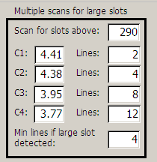

Figure 9 Details on multiple scans

## Reports

Based on various tests defined under the manufacturing tests tab, reports tab can be set up to list results from these individual tests (Figure 10).

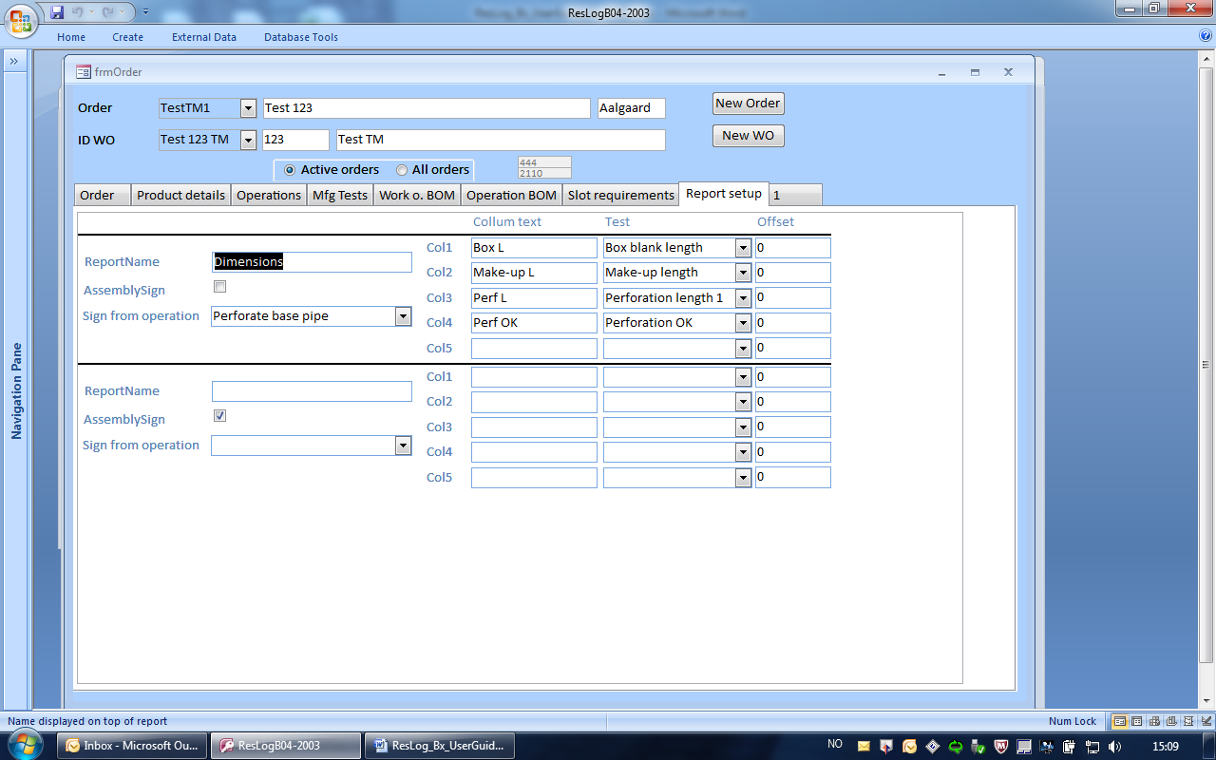

Figure 10 Report setup form

The administrator is able to customize the tests which he wants to display at the assembly report. Each report may include up to 5 columns of data selectable form the various tests recorded. Report name is what has been input on the top of the report

# Ware House

From ResLog Version B, ‘Ware House’ model is added to allocate the traceability of the components used for each joint. To enable the operator to choose the correct parts which he uses to build the joint, the administrator need to allocate all components with traceability information at function ‘Ware House’. Click ‘Ware House’ when ResLog starts (Figure 10)

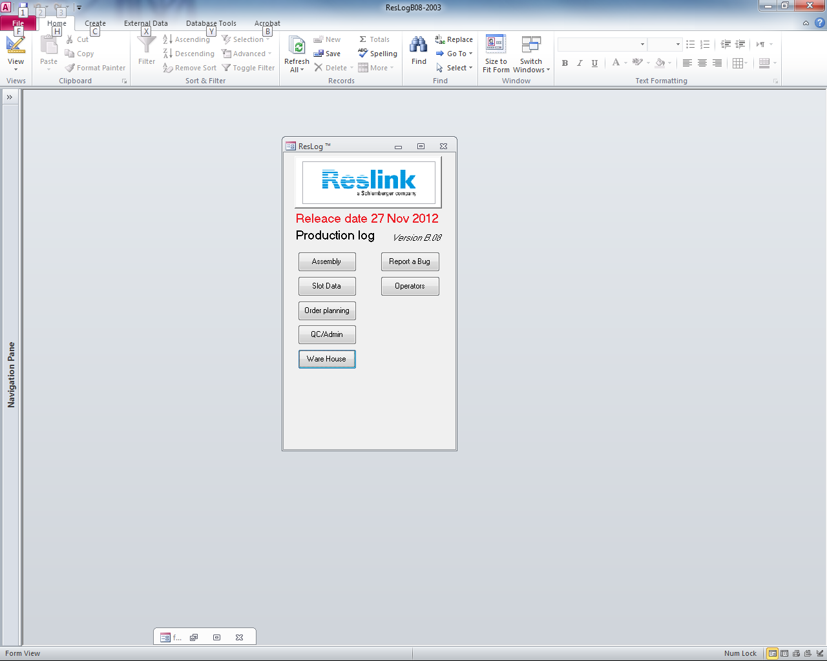

*Figure 10 ‘Ware House’ model to allocate parts*

A form is generated for the administrator to allocate the components with traceability. The BOM is displayed on top as a list box. By choosing the order and work order ID from the drop-down list, a list of the components which the administrator input to Work O. BOM (See section Work o. BOM) is displayed at ResLog. (Figure 11) Select the part from the bill of material and input traceability information. This shows total requirement based on Work o. BOM and quantity in Product details. Alloc is quantity currently allocated for this work order and Used shows how much has been used in the assemblies up to now.

To record traceability, select a part. Part and part information with table for recording of information is displayed below. Record traceability information as displayed on the parts and quantity in the batch. If the part is a wrapping wire, record wire width [mm] and standard deviation of the wire width [µm]

The form allows partially input of allocating parts. This function allows the administrator to input more than single traceability for the same components. The total quantity of the parts allocated could be more than the quantity displayed at ‘total’ to cover more components issued to the work order, e.g. rework. For wrapping wire (based on type of component in the Work o. BOM) wire width and standard deviation should also be recorded.

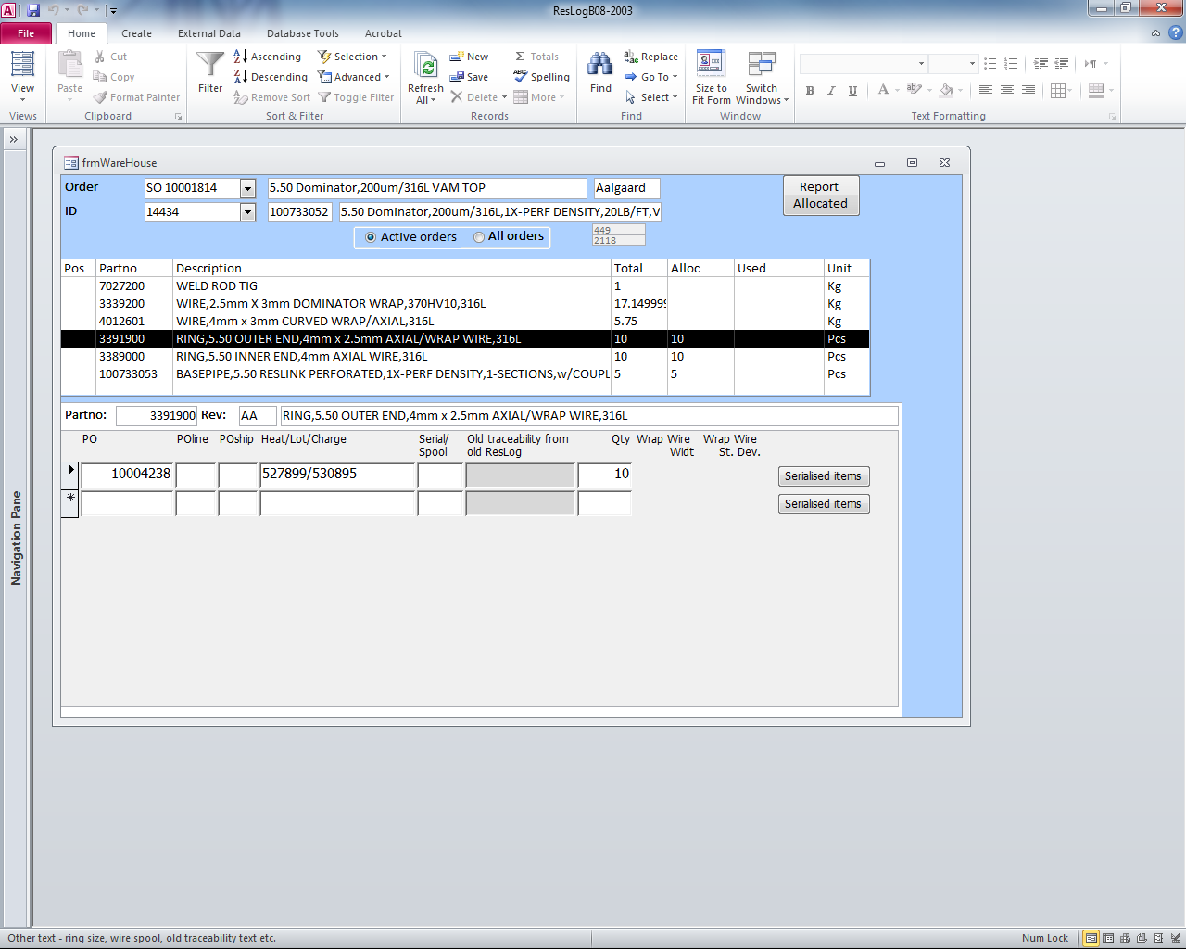

*Figure 11 Warehouse form for allocation of components*

The administrator is able to serialise the components such as base pipe by clicking the ‘Serialised items’ button on the right of traceability input line (Figure 12). Also the administrator is able to manually input the serial number at the form later if the serial number is not continuous in one order.

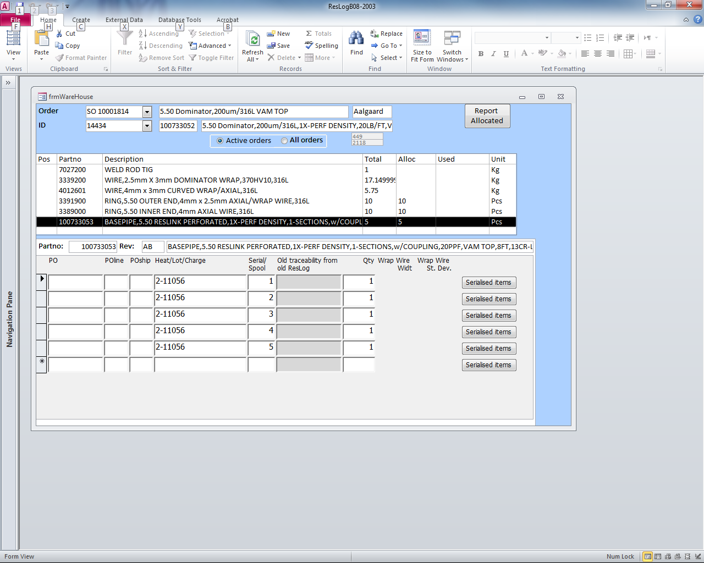

*Figure 12 Input serialised components by clicking ‘Serialised items’*

After input all the traceability of all the components, the setup of allocation parts at ‘Ware House’ model is completed. The operator is now able to pick up the components he uses at each operation at ‘Assembly’ model.

# QC/Admin



This is a set of forms to be used by QC and planners during the execution of an order. Progress of the order can be reviewed and information like hardness and pull off values can b recorded.

## ID status

Status for the given work () order summarised number of closed and open non conformances along with the relative progress of the given joint based on total number of operations.

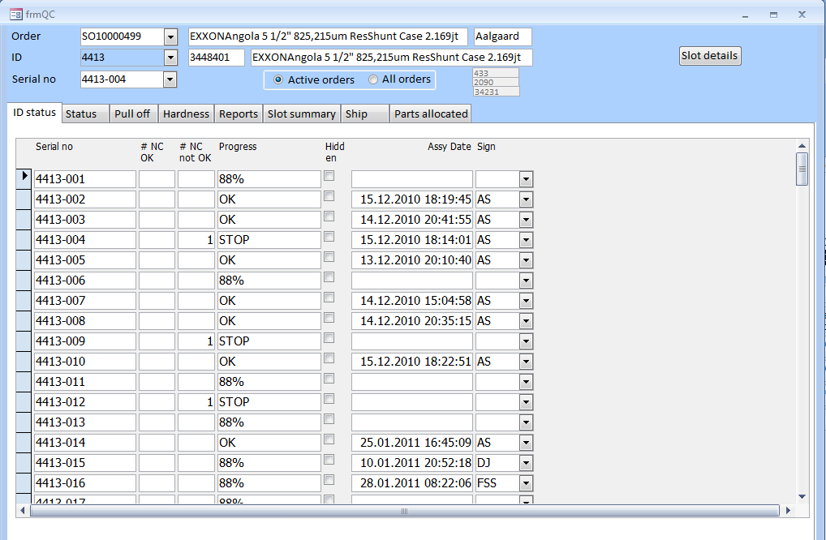

Figure 12 Ware house form for allocation of parts

The hidden check box is not currently available but is intended to indicate that a complete joint is scraped or in other ways removed from the work order.

## Status

QC status for the selected assembly can be reviewed ().

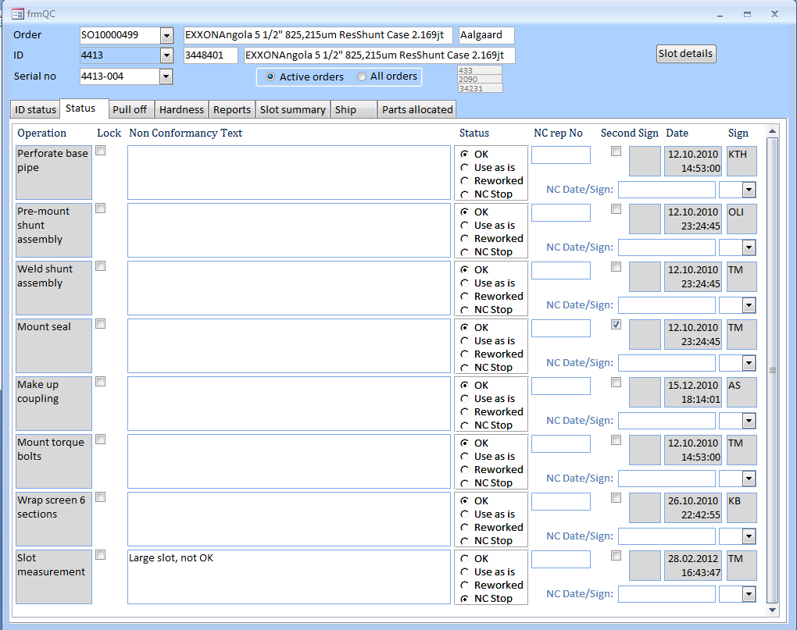

Figure 13 QC status for selected joint

The Lock check box for each operation indicates that the given operation is locked and cannot be edited by the operator (Assembly form). QC has access to unlock a given operation to allow the operator to modify already entered information.

The status can be changed if the status has been set to NC Stop by the operator. In this case status can be set to Use as is or Reworked. If status is changed, QC must sign off and eventually record reference to any non conformance report.

## Pull off

Pull off values () and hardness values (next tab) can be recorded in these forms.

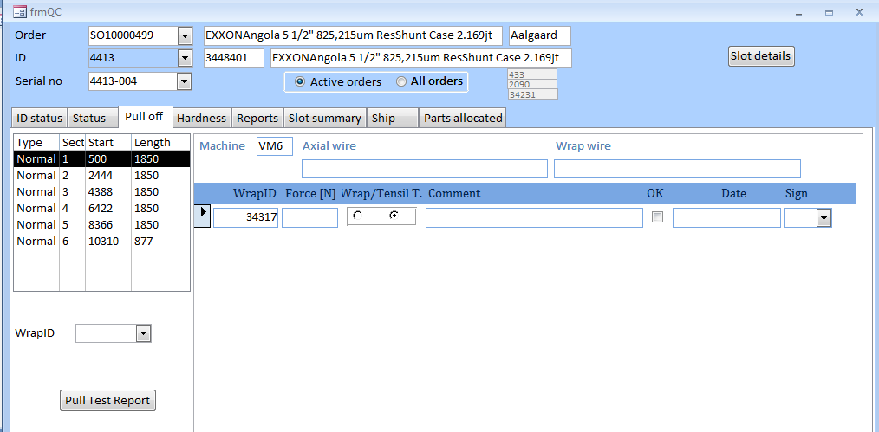

Figure 14 Ware house form for allocation of parts

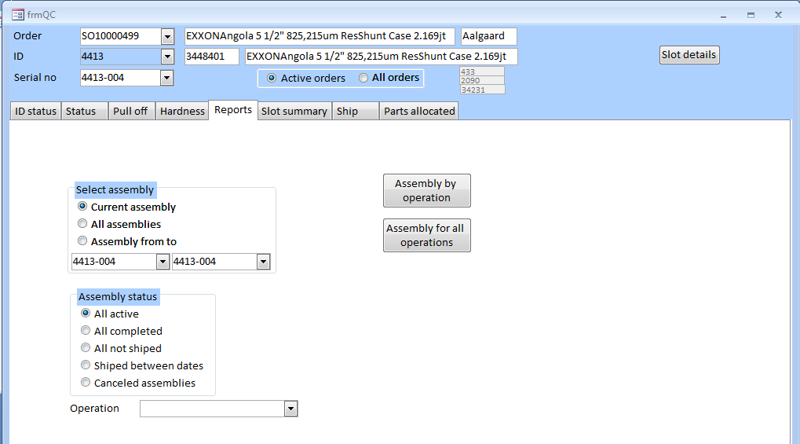

Figure 15 Ware house form for allocation of parts

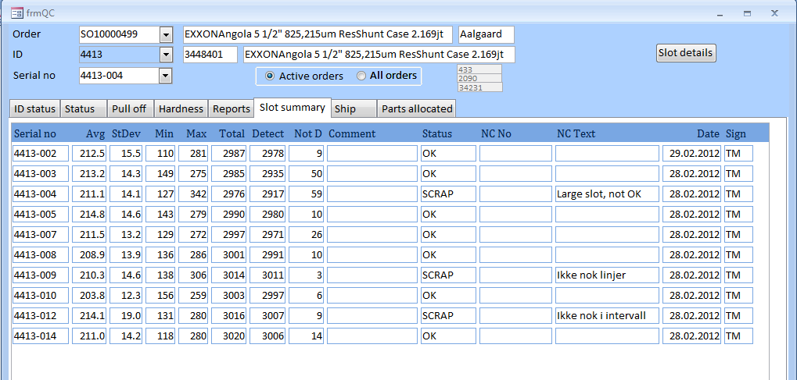

Figure 16 Ware house form for allocation of parts

# Assembly

See user guide part 2

To start assembly process